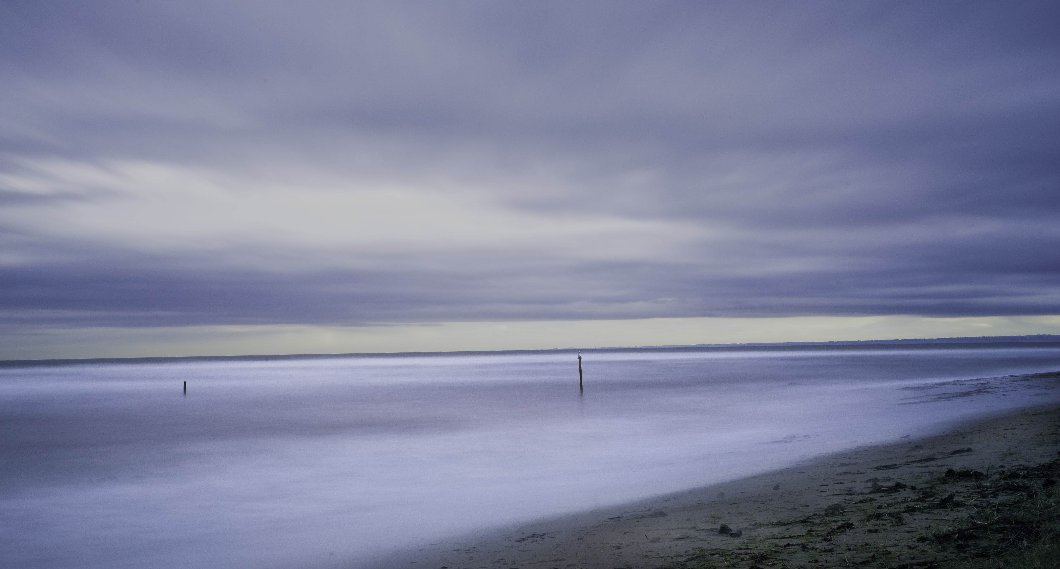

OPEN PHOTOGRAPHIC COMPETITION

The Carnoustie Gala Committee in association with Carnoustie Photo Group is holding an open photographic competition open to all residents within Angus County. The Gala Committee at their annual prize giving in September will present the winner with a trophy. There is no specific topic but photographs must have been taken within Angus County.

Details of entry:-

1) The closing date for entries is Friday 26th June 2015.

2) Photographs should be unmounted and up to A4 size.

3) Entrants should put the title, their name, address and any contact

telephone number on the back of the photograph.

4) Only one photograph per entry.

5) Entries should be handed in to Carnoustie Leisure Centre

Links Parade, Carnoustie or Arbroath Library by 26th June.

6) It is hoped to have the competition judged by an

independent photographer